U10 Build Out Line

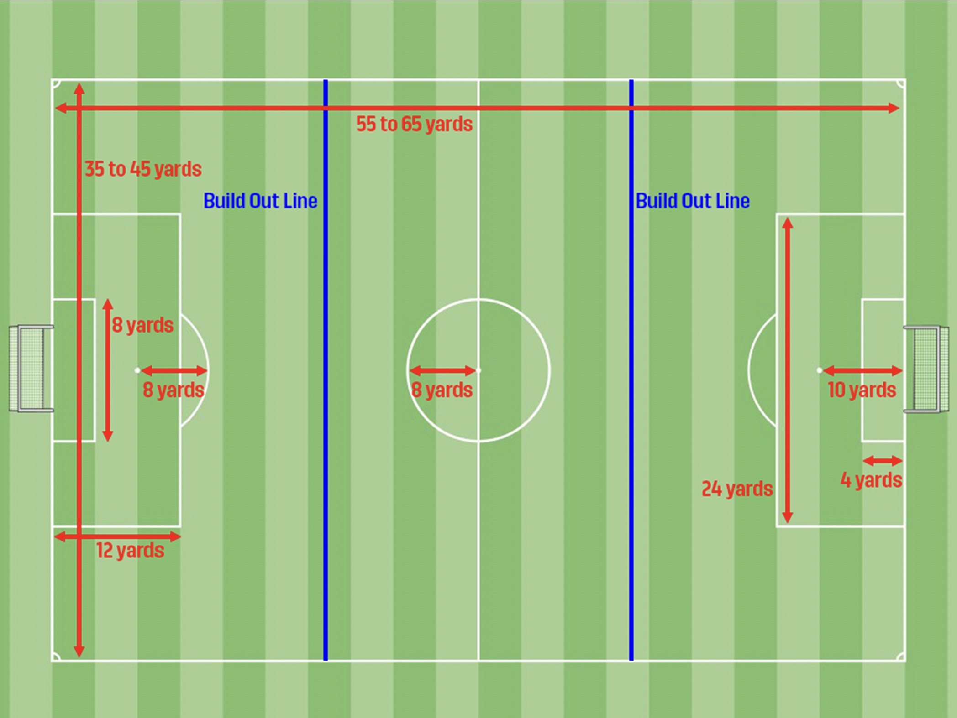

- The build out line is equidistant from the top of the penalty box to the mid line on each side of the field.
- When the goalkeeper has the ball, either during play or from a goal kick, the opposing team must move behind the closest build out line.
- As soon as the goalkeeper has the ball, he or she has a choice: hold the ball and wait for the opposing team to retreat behind the closest build out line, or release the ball by throwing it, rolling it or placing it on the ground and kicking it. Punting or drop kicking is not allowed.
- NOTE: IF the goal keeper chooses to immediately release the ball, the opposing team may attack as soon as the ball is released, even if the ball is in the penalty box area.
- NOTE: IF the goal keeper chooses to hold the ball and wait for the opposing team to retreat behind the build out line, the opposing team must wait for the ball to clear the penalty area before they attack.
- If the goal keeper punts or drop kicks the ball, the opposing team is awarded an indirect free kick at the spot of the infraction. If the infraction occurs in the goal box, the ball is moved parallel to the goal line until just outside the goal box. The indirect kick is taken from there.
- If the opposing team fails to retreat behind the build out line, the referee will delay play until they comply.
- NOTE: Off side is not called in between the two build out lines (the middle of the field). Off side is called at either end of the field, between the build out line and the goal line.
- Goal kicks are taken from the top of the penalty box (not the goal box), and the opposing team must move behind the build out line and remain there until the ball is kicked.

