U10 Build Out Line Info Sheet – Updated 2026

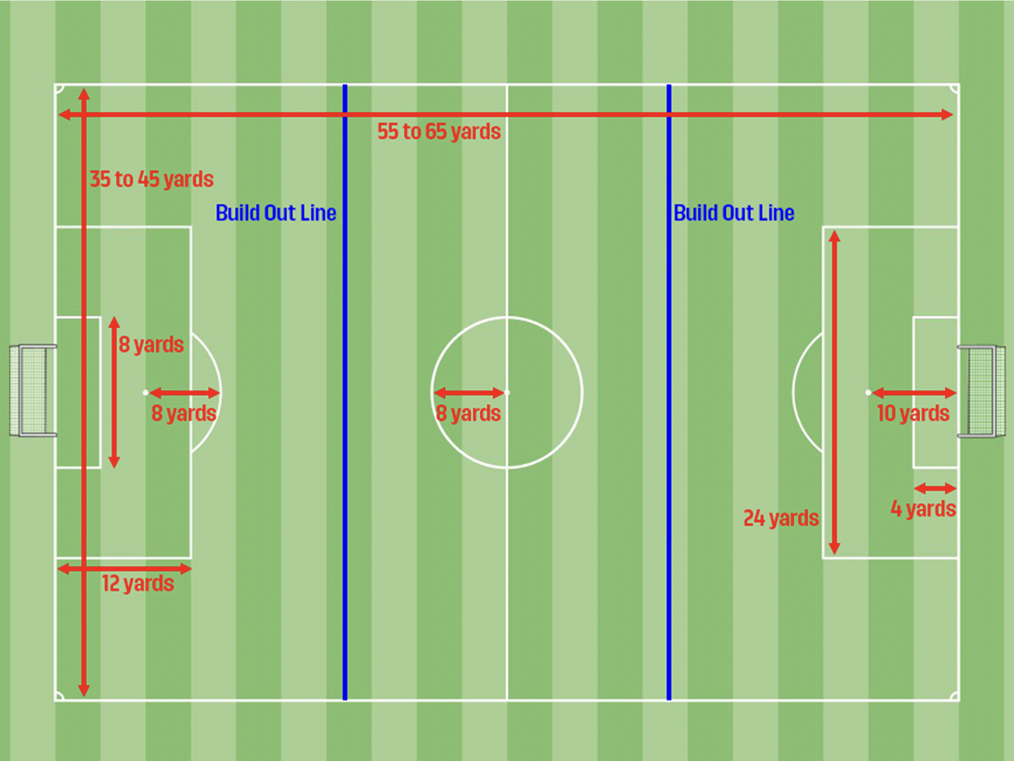

- The build out line is equidistant from the top of the penalty box to the mid line on each side of the field.
- When the goalkeeper has hold of the ball, either from making a save or preparing for a goal kick, the opposing team must move behind the closest build out line.
- As soon as the goalkeeper has the ball (saved a goal), he or she has a choice: hold the ball and wait for the opposing team to retreat behind the closest build out line, or release the ball by throwing it, rolling it or placing it on the ground and kicking it. Punting or drop kicking is not allowed.
- NOTE: IF the goal keeper chooses to immediately place the ball on the ground to be kicked or throw the ball, the opposing team may attack as soon as the ball is kicked or thrown, even if the ball is in the penalty box area.
- NOTE #2: IF the goal keeper chooses to wait to put the ball into play, the opposing team MUST retreat behind the build out line and wait to attack until the goalkeeper has actively played the ball by throwing it or kicking it. This includes placing the ball on the ground in order to kick it. If in this scenario, the goal keeper chooses to place the ball on the ground and is preparing to kick it, the opposing team must wait until the ball is kicked before they attack. The purpose of the build out line is to give teams the opportunity to play from the back. This rules adheres to the spirit of that. This is specific to CSA. In other leagues, including comp, players may attack the ball as soon as it is placed.
- If the goal keeper punts or drop kicks the ball, the opposing team is awarded an indirect free kick at the spot of the infraction. If the infraction occurs in the goal box, the ball is moved parallel to the goal line until just outside the goal box. The indirect kick is taken from there.
- If the opposing team fails to retreat behind the build out line, the referee will delay play until they comply.
- Off side is not called in between the two build out lines (the middle of the field). Off side is called at either end of the field, between the build out line and the goal line.
- GOAL KICKS; the ball must be placed on the top of goal box. Kicking team players can be in the penalty box. Opposing team must be behind the buildout line until the ball is kicked.

